**Top 'K' Elements**

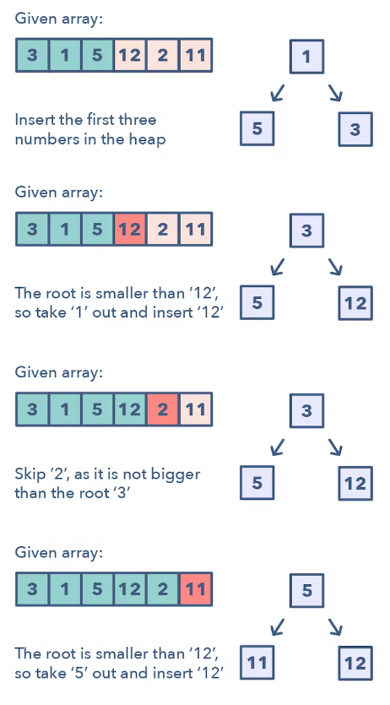

**Ways to Identify the pattern:**

* If you’re asked to find the top/smallest/frequent ‘K’ elements of a given set
* If you’re asked to sort an array to find an exact element

**Common problems you use the sliding window pattern with:**

* Top ‘K’ Numbers (easy)
* Top ‘K’ Frequent Numbers (medium)

**Strategies to Solve the Problem:**

* Spend some time thinking if maxheap or minheap will be used.